Project Design Phase
Solution Architecture

Date | 27 June 2026
Team ID
Project Name | SB Stocks – Paper Trading Platform
Maximum Marks | 4 Marks

Solution Architecture
Solution Architecture defines the overall structure and design of the SB Stocks – Paper Trading Platform. It bridges the gap between business requirements and technical implementation by describing how different components interact to provide a secure, scalable, and efficient stock paper trading experience.
The architecture is based on the MERN Stack, where the frontend is developed using React.js, the backend is built with Node.js and Express.js, and the database is MongoDB Atlas. User authentication is implemented using JWT (JSON Web Token) to ensure secure access to protected resources.
The architecture follows a Three-Tier Architecture, consisting of:

Presentation Layer
- React.js
- Bootstrap
- HTML5
- CSS3
- JavaScript
This layer provides an interactive and responsive user interface where users can register, log in, view stocks, manage their portfolio, and track transactions.

Application Layer
- Node.js
- Express.js
- REST APIs
- JWT Authentication
This layer processes business logic including:
- User Registration
- User Login
- Authentication
- Stock Management
- Portfolio Management
- Buy/Sell Operations
- Transaction Processing

Data Layer
- MongoDB Atlas
This layer stores all application data including:
- User Details
- Stock Information
- Portfolio Records
- Transaction History

Solution Architecture Diagram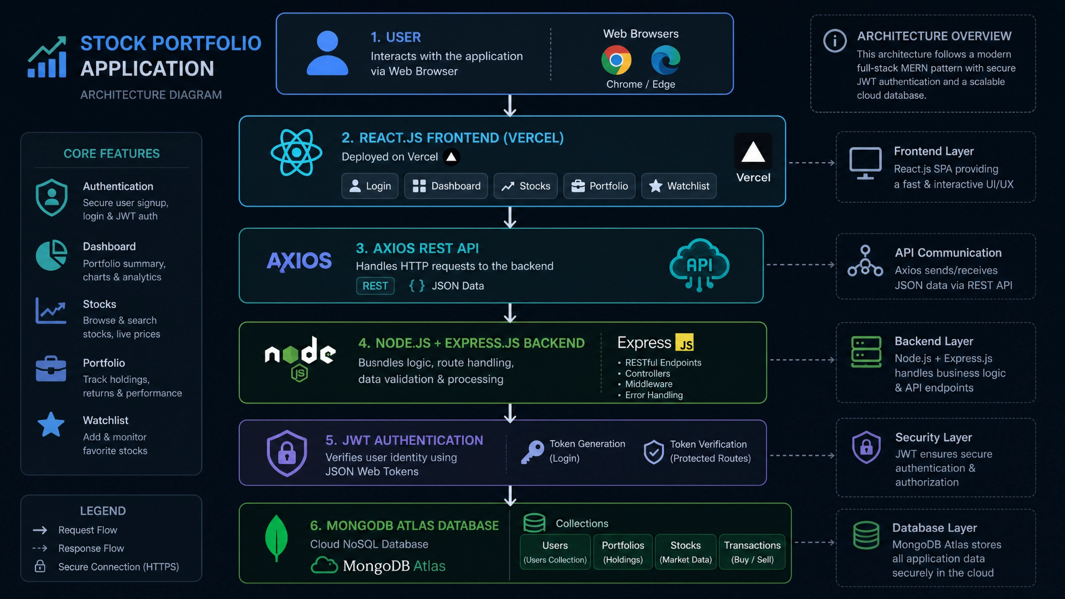

Architecture Workflow

Step 1
The user opens the SB Stocks application through a web browser.

Step 2
The React.js frontend displays the Login or Registration page.

Step 3
The user submits login or registration details.

Step 4
The frontend sends the request to the Express.js backend using REST APIs.

Step 5
The backend validates user credentials.

Step 6
After successful authentication, a JWT token is generated and returned to the frontend.

Step 7
The JWT token is stored in the browser's Local Storage.

Step 8
Authenticated users can:
- View Dashboard
- Browse Stocks
- Buy Stocks
- Sell Stocks
- View Portfolio
- Check Transaction History

Step 9
The backend performs CRUD operations on MongoDB Atlas.

Step 10
The updated information is sent back to the frontend and displayed to the user.

Key Features of the Architecture
- Three-Tier Architecture
- Secure JWT Authentication
- RESTful API Communication
- Cloud Database (MongoDB Atlas)
- Responsive React.js Frontend
- Modular Express.js Backend
- Cloud Deployment using Vercel and Render
- Scalable and Maintainable Design

Technologies Used
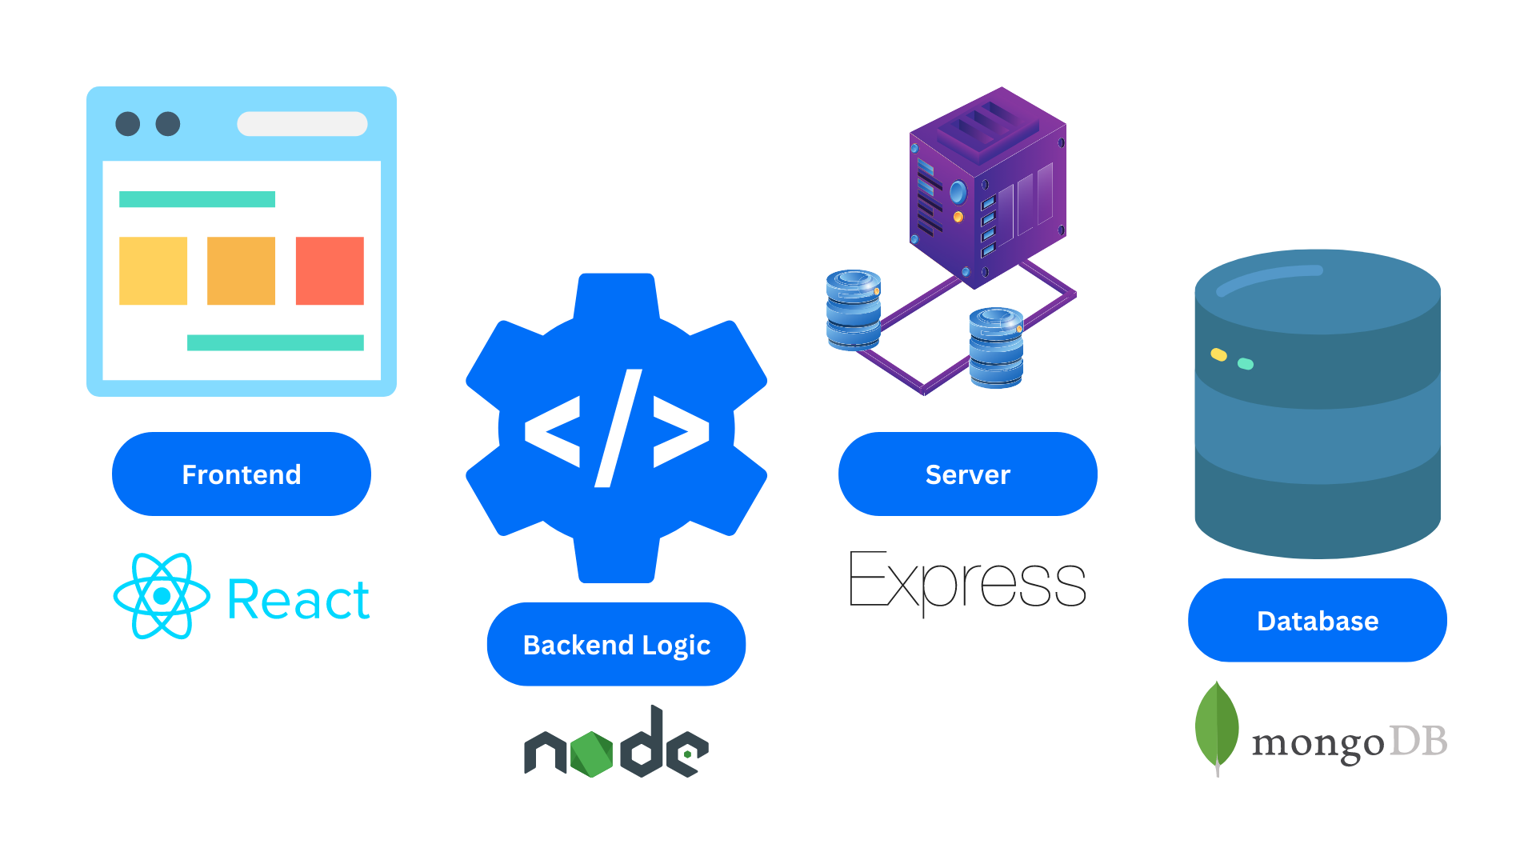
Layer | Technology
Presentation Layer | React.js, Bootstrap, HTML, CSS, JavaScript
Business Layer | Node.js, Express.js
Authentication | JWT
Database | MongoDB Atlas
API Communication | Axios
Frontend Hosting | Vercel
Backend Hosting | Render

